Computer Language Coding Concepts

Command Call in a Diagram
The principle of a command call is explained in the article Command Call. This article demonstrates its expression in a diagram.

A command call in a diagram is represented by a diamond shape:



This as opposed to a command definition, which is represented by a square:



It needs to be specified which command is called. This is done by connecting the diamond, representing the call, to the square, representing the definition.

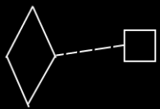

Because the definition is the prototype of the call, and not the same object as the call, a dashed class line needs to be used to point out the definition of a call.

A call is always done from a parent command:

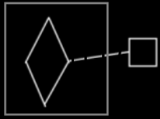

See also: Command Call, Commands

Author & Copyright: Jan-Joost van Zon Date: May 24, 2008 – August 7, 2008 Location: Oosterhout, The Netherlands Status: Finished

